## BuzzHiveGames Sprint Completion: 7/24/18

# Against the Swarm v.1 (7/17/18) Sprint 3 Plan

**Goal:**

**Task Listing: (32 Story Points)**

(5) As a player, I want the game’s look to be consistent and professional, so that I maintain awareness of the game state without being distracted.

* Relative scaling Michael
* Background (grassy field) Andrew
* Town Panel Background
* Add Action Button images to the game Jolene
* Add fire effect on town when under siege (Jolene)
* Add bottom UI and style it
* Add a buttons on the bottom right corner and clicking each button will show a different page of stats (1.5 hr) (Michael)
* Select font and make sure text doesn’t wrap
* Get rid of white margin between town and field panels
* Style technology tree (Brandon)
* Resize resources UI (Brandon)
* Add tooltip box when hovering over technologies

(8) As a designer, I want the statistics of the game, monster/fighter/follower be balances, so that players can expect a certain runtime ~1 hour. Buzz

(8) As a designer, I want the technologies to modify the other statistics in a game in such a way that provides the player with meaningful choices that each feel like they have an impact so that the player is entertained and keeps playing. Buzz

(5) As a designer, I want there to be a way of scoring a player’s run through the game so that they can know their competency and perhaps set goals for future attempts. - Jacob

* Game Over - Jacob
* Scoring system (monsters killed - worlds lost - time taken) - Jacob
* Pause when end is reached - Jacob
* Play again button (refresh) - Jacob

(5) As a game designer, I want the number of followers that the player can take with them when they retreat to a new world to be limited, so that they have to make decisions about who to take with them and if they will hire more miners/teleporters in the next world.

* Display all of the followers/fighters in the modal with numbers. 30 Jacob
* Add followers and fighters to your escape party. 15 Jacob
* If you have a valid escape party, you can click teleport. 20 Jacob
* This modal pops up when you leave a world. 15 Jacob
* You lose all the fighters/followers not in your escape party. 10 Jacob

(3) As a player, I want their to be a Boss Monster Sprites, so that when I’m fighting a boss monster I know what kind of challenge I’m facing, and I can feel good when I overcome it.

* Draw boss monster sprite 1 hour

(3) As a designer, I want there to be a Monster Tracker object in the game that keeps track of what enemies the player has killed so that I can set up systems that respond to player action incentivizing theme to shift strategies. (MIchael)

* Monster types (boss, warrior, drone…) 0.5 hour
* Make a new Tracker object 0.25 hour
* Store how many you killed each and determine which to spawn next 0.5 hour

**Team Roles:**  
Buzz Tilford: Product Owner

Jacob Swanson:

Andrew Kim: Developer, Artist

Zeyuan Jiang: Developer

Jolene Nguyen: Developer

Brandon Pham: Developer

**Initial Task Assignment:**

Buzz Tilford:

Zeyuan Jiang:

Andrew Kim:

Jolene Nguyen:

Brandon Pham:

Jacob Swanson:

**Initial Burn Up Chart:**

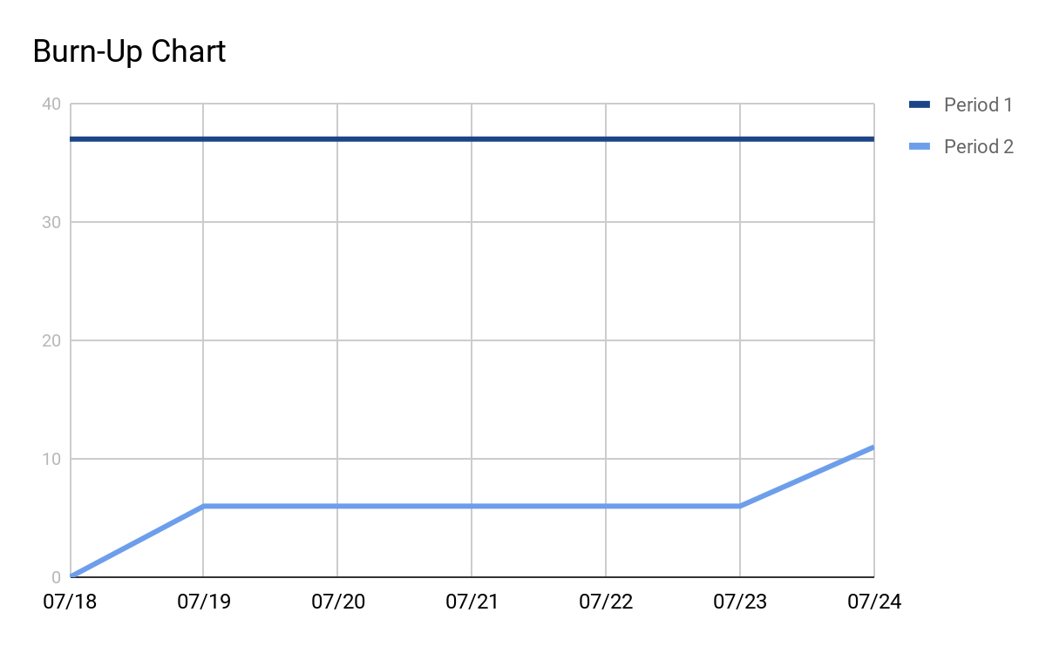

**Initial Scrum Times:**

Tues 12:00 PM with TA BE 340A

Thur 5:30 PM with TA BE 340A  
 Sun 10:00 AM BE 316

**Scrum Board:**

<https://trello.com/b/IKjjFwoM/sprint2>